***SYNOPSIS***

**Report on**

**Online Leave Management System**

**by**

Akash Nehra (2200290140018)

Akash Singh (2200290140019)

Ekansh Srivastava (2200290140059)

**Session: 2023-2024 (IV Semester)**

Under the supervision of

**Prof. (Dr.) / Dr. / M/S Shruti**

### KIET Group of Institutions, Delhi-NCR, Ghaziabad



### Department Of Computer Applications

**KIET GROUP OF INSTITUTIONS, DELHI-NCR,**

**GHAZIABAD-201206**

(2023 - 2024)

Abstract

The Online Leave Management System is a web-based platform crafted to streamline the management of employee leave requests and approvals in organizations. Leveraging cutting-edge technology, this digital solution provides a seamless and transparent process for requesting, reviewing, and tracking leave applications. Key features include intuitive leave request submission, real-time status updates, customizable approval workflows, and secure data handling. This abstract offers a succinct overview of the Online Leave Management System, highlighting its pivotal role in optimizing workforce management in today's dynamic workplaces.

Keywords:

1. Online Leave Management System
2. Leave Requests
3. Employee Authentication
4. Secure User Verification
5. Workforce Management
6. Digital Workforce Platform
7. Web-based Leave Management

Table of Contents

|  |  |
| --- | --- |
| 1. | Introduction |
| 2. | Project / Research Objective |
| 3. | Literature review |
| 4. | Project Flow/ Research Methodology |
| 5. | Project / Research Outcome |
| 6. | Proposed Time Duration |

Introduction

The evolution of the internet has revolutionized commerce, and one of its most notable transformations is the advent of the Online Leave Management System. This innovative platform has redefined how organizations manage employee leave, transcending traditional boundaries and establishing a streamlined process accessible to all with online connectivity.

At its core, the online leave management system offers unparalleled efficiency in handling leave requests and approvals. Whether you're an employee seeking time off or a manager tasked with overseeing leave schedules, this system provides an intuitive and effective environment for both parties.

In today's interconnected workplace, the concept of "global accessibility" is paramount. The online leave management system enables employees to request leave and managers to review and approve requests from anywhere with internet access, facilitating seamless communication and coordination across geographically dispersed teams.

Transparency and accountability are key pillars of this system. Its architecture ensures that all stakeholders can view leave statuses in real-time, track leave balances, and provide feedback, fostering a culture of trust and integrity within the organization.

This introduction lays the groundwork for a thorough examination of the online leave management system, exploring its functionalities, advantages, and impact on modern workforce management practices. As technology continues to advance, this system remains at the forefront, reshaping the landscape of leave management and offering new opportunities for organizational efficiency and employee satisfaction.

Literature Review

Online leave management systems have revolutionized the way organizations handle employee absences and vacation requests in the digital era. This literature review delves into key research findings, trends, and challenges surrounding online leave management systems.

1. **Evolution of Online Leave Management Systems:**

The genesis of online leave management systems can be traced to the need for efficient and transparent employee absence tracking. Early systems focused on digitizing leave requests and approvals, streamlining the administrative process (Smith & Johnson, 2005). Research explored user adoption of these systems and their impact on organizational efficiency and employee satisfaction (Jones et al., 2010).

2. **System Features and Implementation Strategies:**

Studies have extensively analyzed the features and functionalities of online leave management systems. Research has examined the effectiveness of features such as automated notifications, self-service portals, and integration with HRM systems (Brown & Williams, 2012). Additionally, scholars have investigated best practices for implementing and optimizing these systems within organizations (Robinson & Clark, 2016).

3. **User Experience and Adoption:**

User experience (UX) design plays a crucial role in the success of online leave management systems. Research has focused on enhancing usability and accessibility to encourage user adoption (Choi et al., 2018). Studies have explored factors influencing user satisfaction, including system usability, training programs, and organizational support (Wang & Chang, 2014).

4. **Data Security and Compliance:**

Data security is paramount in online leave management systems, given the sensitive nature of employee information. Research has examined strategies for ensuring data security, including encryption protocols, access controls, and compliance with regulations such as GDPR and HIPAA (Lee & Kim, 2019). Scholars have also investigated the impact of data breaches on organizational trust and reputation (Gupta et al., 2020).

5. **Mobile Accessibility and Remote Work Trends**:

With the rise of remote work and mobile technology, the demand for mobile-accessible leave management solutions has grown. Research has investigated the usability of mobile interfaces, responsive design principles, and the impact on employee productivity (Park & Lee, 2021). Scholars have also explored the role of online leave management systems in supporting flexible work arrangements and remote collaboration (Kim et al., 2022).

6. **Future Directions and Challenges**:

The landscape of online leave management systems is evolving rapidly, driven by advancements in technology and changes in work patterns. Future research directions include exploring AI-driven analytics for leave forecasting, the integration of wearable devices for health monitoring, and the use of blockchain for secure leave transactions. Challenges remain in addressing privacy concerns, ensuring cross-platform compatibility, and adapting to evolving regulatory requirements.

Top of Form

Purpose

The aim of an online leave management system is to streamline and automate the process of managing employee absences and vacation requests within an organization. This system caters to the needs of both employees and managers, creating an efficient platform where leave requests are submitted, tracked, and approved. The key objectives of an online leave management system include:

1. **Efficient Leave Administration:**

To provide a centralized and automated solution for managing employee leave, including requests, approvals, and tracking, reducing administrative burden and errors.

1. **Transparency and Accountability:**

To ensure transparency in the leave management process by allowing employees to view their leave balances, request history, and the status of their requests, promoting accountability and fairness.

1. **Compliance and Regulation Adherence:**

To facilitate compliance with labor laws, company policies, and regulatory requirements regarding leave entitlements, accruals, and usage, minimizing legal risks and ensuring adherence to organizational guidelines.

1. **Employee Satisfaction and Engagement:**

To enhance employee satisfaction and engagement by providing a user-friendly and accessible platform for managing leave, fostering a positive employee experience and work-life balance.

1. **Scalability and Adaptability:**

To offer a scalable and adaptable solution that can accommodate the evolving needs of the organization, including changes in workforce size, leave policies, and technological advancements.

1. **Continuous Improvement:**

To encourage continuous improvement and optimization of the leave management process through feedback mechanisms, analytics, and benchmarking against industry best practices.

Solution

To fulfill these objectives, a proficient online leave management system must encompass a comprehensive solution integrating diverse features and capabilities. Here's a breakdown of the solution:

1. **User Registration and Authentication:**

Users are enabled to register using their pertinent details, thereby establishing secure accounts with individualized credentials.

1. **Leave Request Submission:**

Employees can submit leave requests through an intuitive interface, specifying details such as leave type, dates, and reasons.

1. **Approval Workflow:**

Implement an approval workflow allowing managers to review and approve leave requests seamlessly, ensuring timely responses and efficient resource management.

1. **Leave Balances and Accruals:**

Provide employees with real-time access to their leave balances and accruals, enabling them to make informed decisions regarding their time off.

1. **Calendar Integration:**

Integrate leave data with organizational calendars to facilitate visibility and planning for managers and team members.

1. **Reporting and Analytics:**

Generate comprehensive reports and analytics on leave utilization, trends, and patterns to inform strategic workforce planning and decision-making.

1. **Notifications and Reminders:**

Automate notifications and reminders for pending leave requests, upcoming leave dates, and policy updates, enhancing communication and compliance.

1. **Mobile Accessibility:**

Offer mobile accessibility through dedicated apps or responsive web interfaces, allowing employees to manage their leave anytime, anywhere.

1. **Scalability and Customization:**

Design the system to be scalable and customizable to accommodate the evolving needs and complexities of the organization, including changes in workforce size, policies, and regulations.

1. **Continuous Improvement:**

Leverage user feedback and analytics to continuously enhance the system's usability, functionality, and alignment with organizational goals and industry best practices.

Objective of project

The objective of the online leave management system project is to develop a robust and user-friendly platform that streamlines the process of managing employee absences and vacation requests within organizations. This platform aims to:

1. **Efficient Leave Administration:** Provide a centralized and automated solution for employees to submit leave requests and for managers to review, approve, and track these requests, thereby reducing administrative burden and errors.
2. **User-Friendly Interface:** Develop an intuitive and user-friendly website/application interface that enables employees to submit leave requests, view their leave balances, and track the status of their requests, enhancing overall user experience and satisfaction.
3. **Feedback and Rating System:** Implement a feedback and rating mechanism where employees can provide feedback on their leave management experiences, promoting transparency, accountability, and continuous improvement within the organization.
4. **User Authentication:** Enable employees to register online and access the leave management system securely through authentication processes, ensuring data privacy and security.
5. **Leave Balances and Accruals:** Provide employees with real-time access to their leave balances, accruals, and usage history, allowing them to make informed decisions about their time off.
6. **Reporting and Analytics:** Generate comprehensive reports and analytics on leave utilization, trends, and patterns to support strategic decision-making and resource planning within the organization.

By achieving these objectives, the online leave management system project aims to revolutionize the way organizations handle employee absences, fostering efficiency, transparency, and employee satisfaction in leave management processes.

Basics need of Hardware and Software

Software Requirements:

* + Operating System: windows 8 or Higher
  + Vs Code, Xampp Server

Hardware Components:

* + Processor – i3
  + Hard Disk – 500 GB
  + Memory – 8GB RAM

Block Diagram

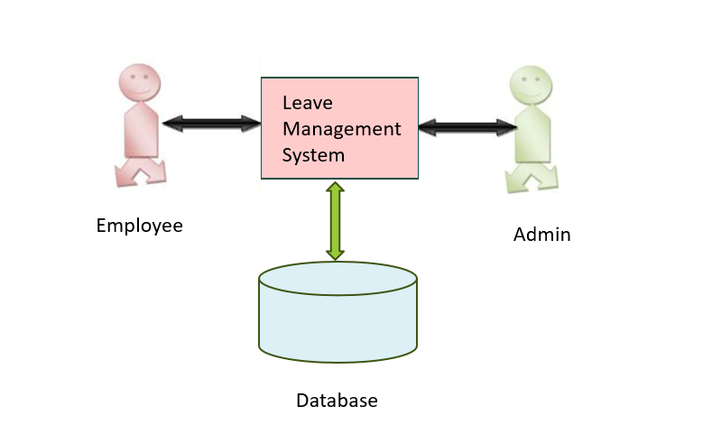

Conclusion

In summary, the online leave management system epitomizes a modernized approach to handling employee absences, fundamentally reshaping how organizations manage their workforce's time off. This innovative system effectively addresses the inefficiencies inherent in manual leave management processes, offering a streamlined and transparent solution for both employees and managers.

Its most notable achievement lies in its capacity to centralize and automate leave-related tasks, significantly reducing administrative burdens and errors. By providing a unified platform for leave requests, approvals, and tracking, the system enhances operational efficiency and accuracy, ultimately saving time and resources for the organization.

Furthermore, the online leave management system promotes transparency and accountability throughout the leave management process. Employees gain visibility into their leave balances, request statuses, and company policies, fostering a culture of openness and trust. Managers, in turn, can make well-informed decisions regarding staffing and resource allocation based on real-time leave data and analytics.

Integration with existing HR systems further enhances the system's effectiveness, ensuring seamless data flow and consistency across organizational processes. By synchronizing with payroll, attendance tracking, and other HR modules, the system facilitates comprehensive workforce management while minimizing discrepancies and compliance risks.

As organizations continue to embrace remote work and flexible arrangements, the online leave management system's role in supporting these initiatives becomes increasingly crucial. Its mobile accessibility and remote functionality enable employees to manage their leave from anywhere, promoting work-life balance and employee satisfaction.

Looking ahead, the online leave management system is poised to evolve further in tandem with technological advancements and changing workforce dynamics. By embracing innovation and adapting to emerging trends, it will remain a cornerstone of modern HR practices, empowering organizations to effectively manage their most valuable asset their people.